|  |
| --- |
| School of Media Studies and IT |
| **XML/JSON Data Processing** |
| ITC5202 - Project |
|  |
| **Yashkumar Patel**  **Submission Date** |
| **4/14/2019** |

|  |
| --- |
| This document explains how to process XML/JSON data …………………………. |

Table of Contents

Question 1: Use JavaScript/Ajax to process XML data 2

Question 2,3,4,6: Use JavaScript/jQuery to process JSON data 3

Question 5 and 7(Bonus) : XSLT and XPath 4

Summary 5

# Question 1: Use JavaScript/Ajax to process XML data

(Describe the major steps for designing the JavaScript function(s), how you test this program, add some screenshots of the output)

*First step was opening xml file using jquery, ajax*

*functions :$(document).ready(function(){}),$.ajax()*

*Second was creating foreach loop for country tags from the xml*

*Functions:$(data).find(‘country’)*

*Third was selecting appropriate tags and attribute from the xml file.*

*$(this).find('name:first').text()*

*Fourth was to generate table using collecting Data.*

*'<tr><td>'+ countryname+ '</td></tr>'*

For testing purpose, we used XAMPP as a sever and Mozilla Firefox as a web browser.

Screen Shot:

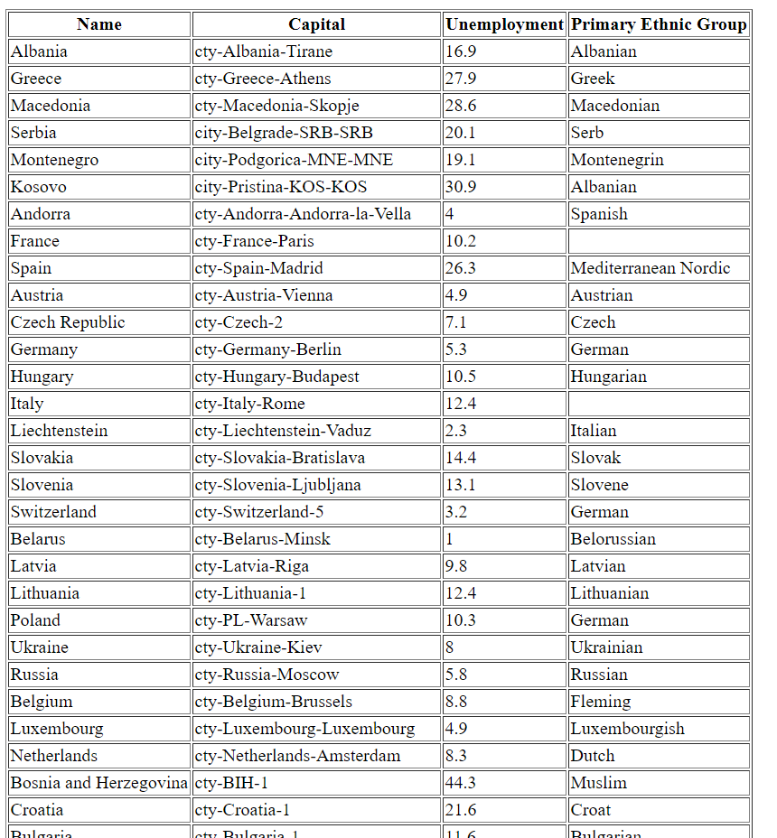

# Question 2,3,4,6: Use JavaScript/jQuery to process JSON data

(Describe the major steps for designing the JavaScript function(s), how you test this program, add some screenshots of the output)

First Step was opening json file using ajax

Function: $(document).ready(function(){}),$.ajax(url: success: error:)

Second Step was loop through Main array element in json file.

Function:$.each(data,function(index,value))

Third Step was selecting required elements and arranging data according.

For Testing We used Mozilla Firefox as a browser and XAMPP as a Web Server and for error resolving we used console of web browser.

Screen Shots:

Question 2:

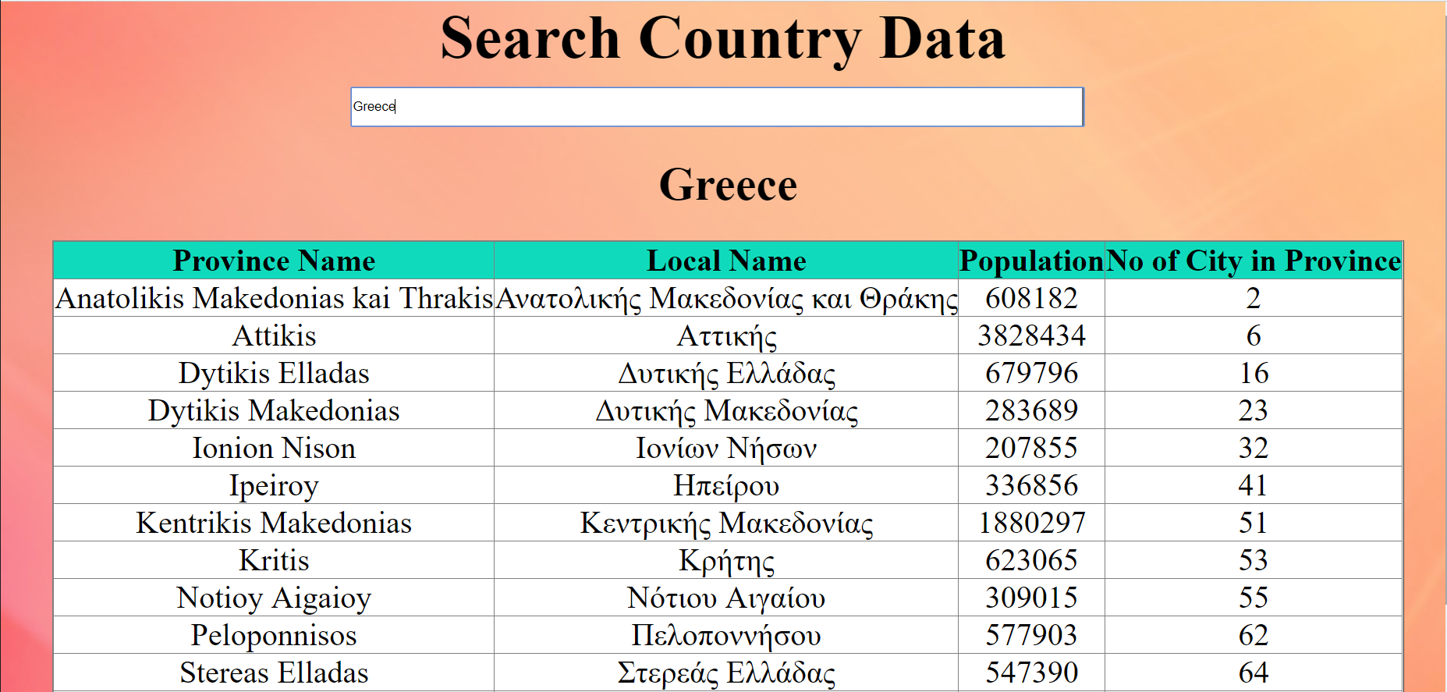

Question 3:

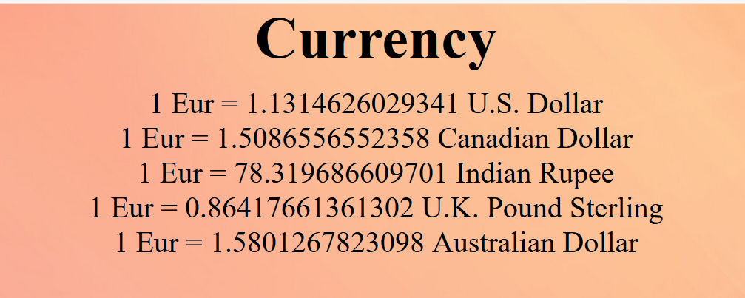

Question 4:



Question 6:

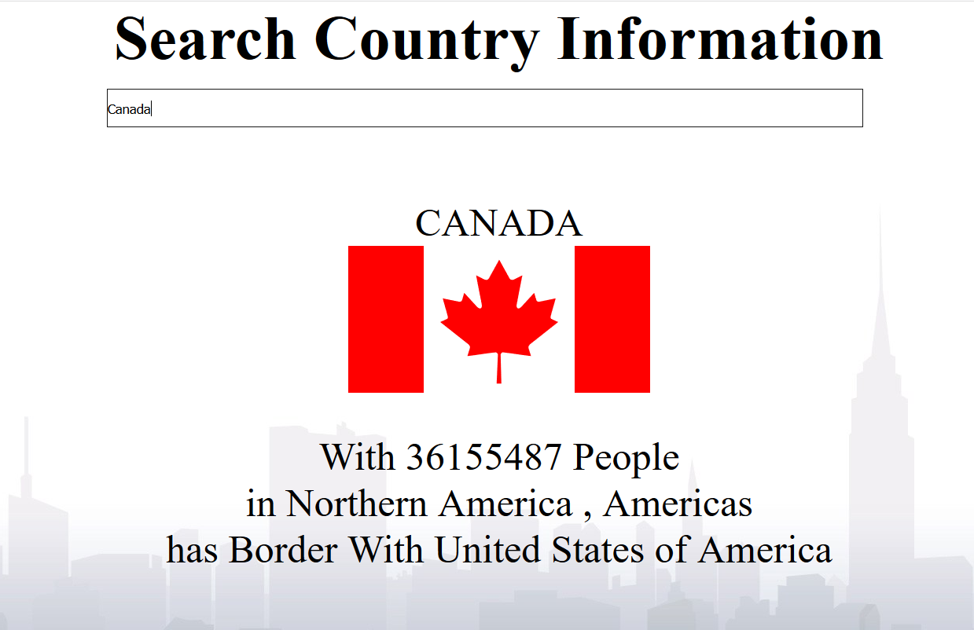

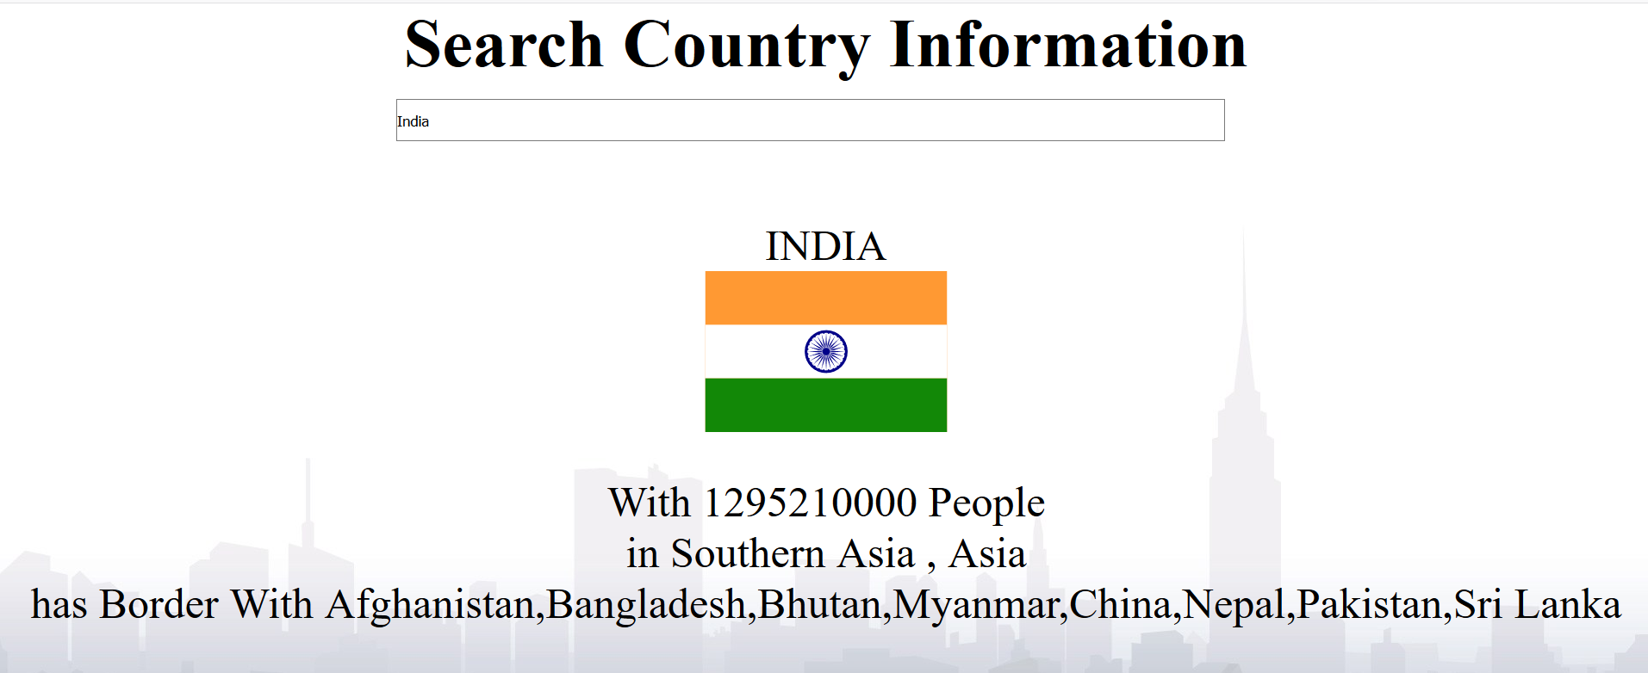

# Question 5 and 7(Bonus) : XSLT and XPath

(Describe the major steps for designing the XSLT. How did you use XPath in the XSLT?

Add screenshot of the XPath testing and the output of XSLT)

First Step was selecting appropriate XPATH to select parent element using Xsl template



Second Step was select looping element for that we used xsl:for-each.



Third Step was required elements from xml file for that we used xsl:value-of and select property of that element to specify xpath.

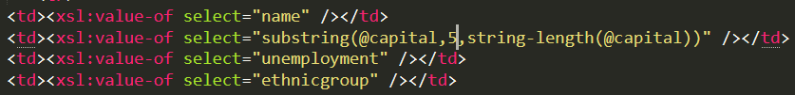

We use XPATH to select specified element from xml for testing we used web browser console.

Screen Shots:

Question 5:

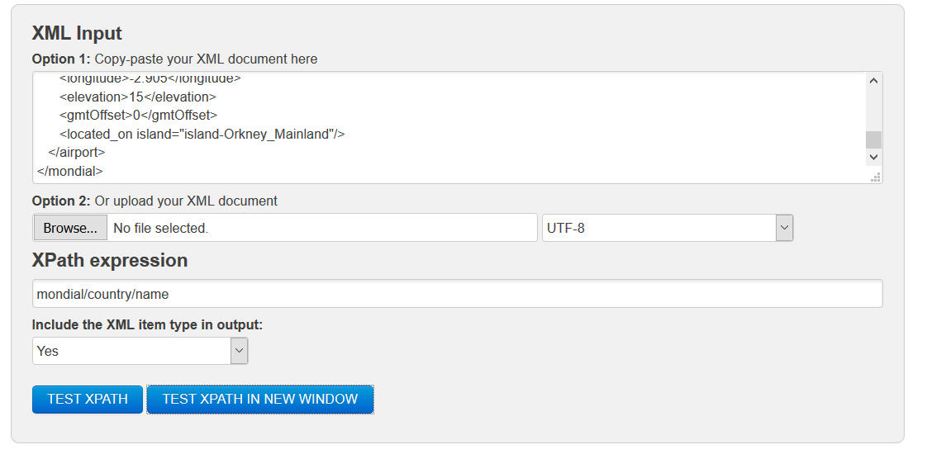

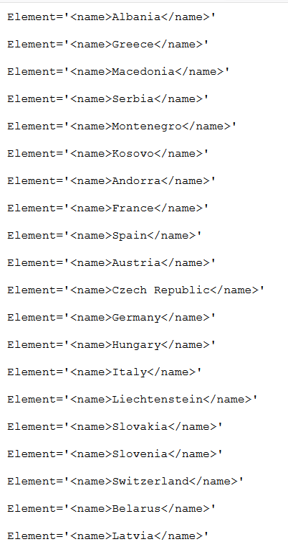

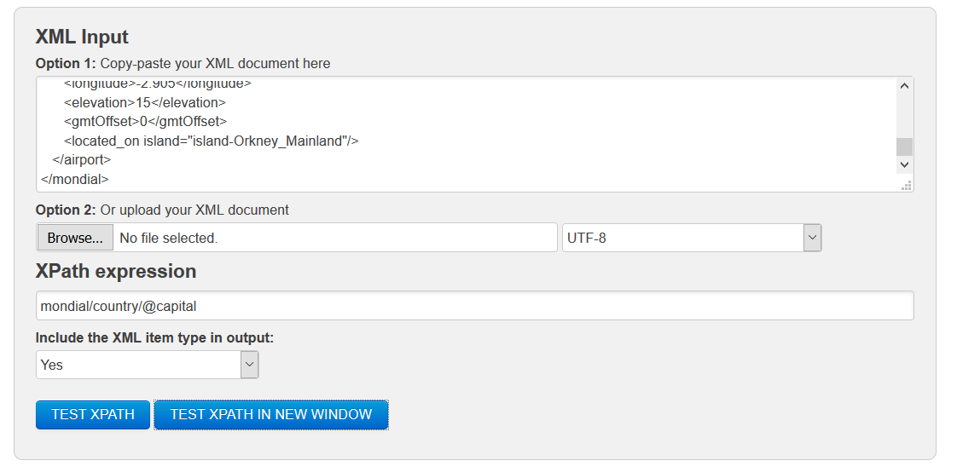

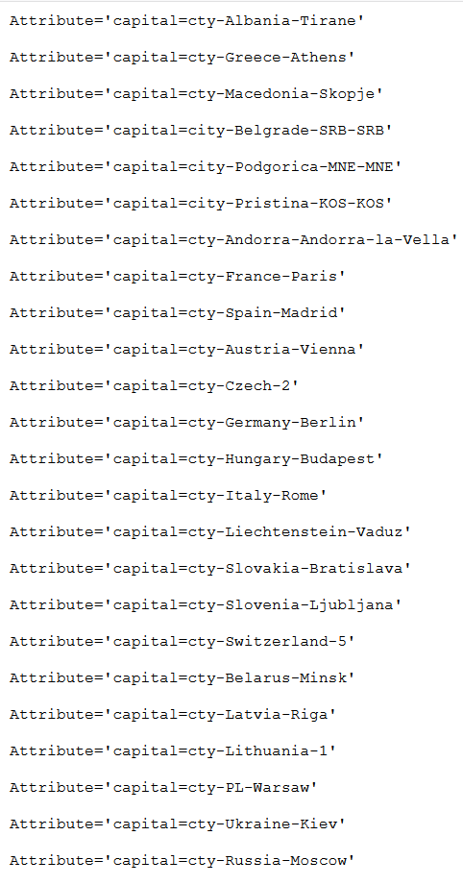

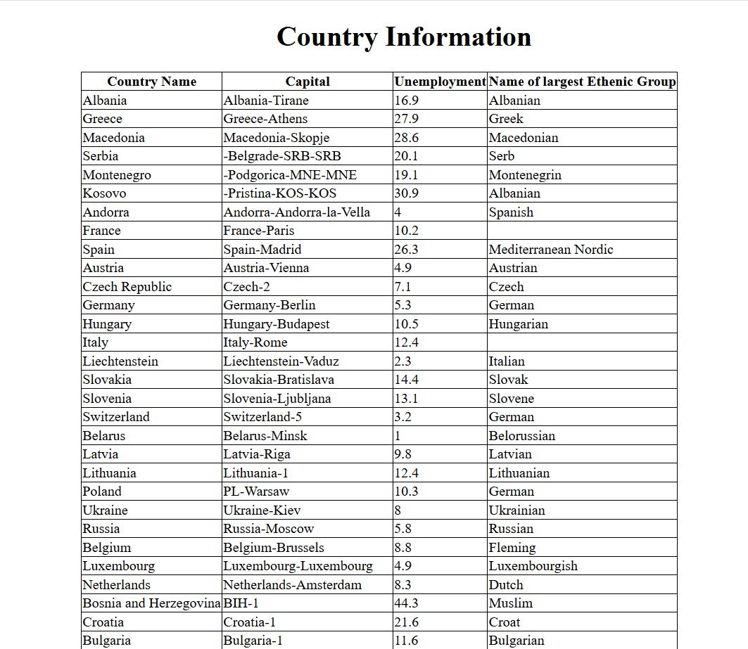

Question 7:

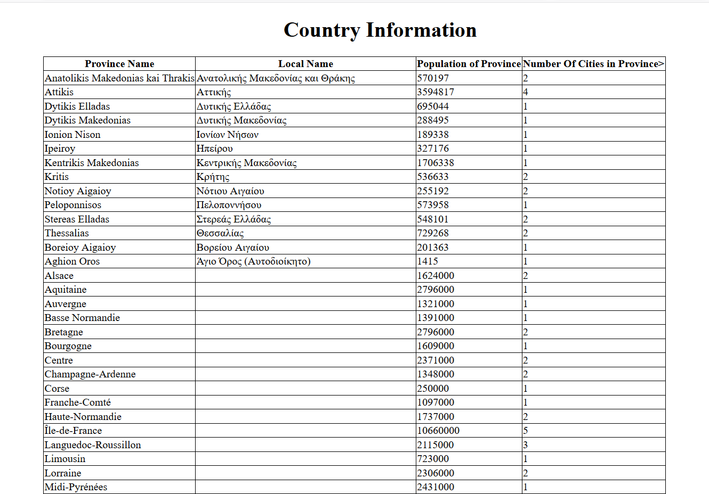

# Summary

(Describe how did you divide the work, share your feedback about this project like new points that you learn, challenges, …)

In Class We decided that Mehmat will start working on question 1 and I will start work on question 2 So he did Question 1and I did Question 2 and Question 3. Question 4 was incomplete in class.

After Class we decided he will do Question4, but I didn’t get any reply. So, I did Rest of the Question4, Question 5, Question 6.

I Learn so many things like how to manipulate large real-life data and access specific elements recap XPATH AND XSLT concepts We learned how to access data from different type of apis.

For Question 2 biggest challenge was selecting province because there were some countries who don’t have province so we can’t select same structured access path for all the elements. For Question 4 biggest problem was Combining two different apis and get data combining them. Question 5 was not that hard but I have to recall all the concept of XSLT and XPATH. Question 6 was almost same as question 2 but most difficult part was getting full name of border countries because from api we can get only alpha3code of all countries so that was bit challenging.

Overall this Project was very good learning process and we learned so many new thing we get to know about some good free apis.